
Village of Consort Community Survey: Museum Funding
Your feedback is crucial to ensure that the Village funds are allocated in a way that best serves our community's interests. Please take a moment to share your thoughts and help shape the future of our museum.
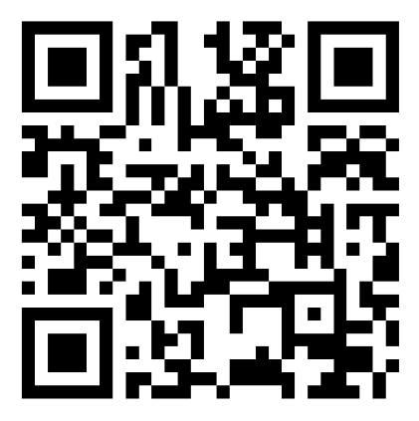
https://forms.office.com/r/tYNwyehXWt

